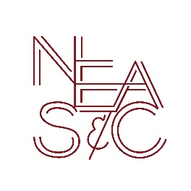

New England Association of Schools and Colleges, Inc.

Commission on Independent Schools

1115 Westford Street, Third Floor, Lowell, MA, 01851 USA

Release of Financial Information

The (Arch) Diocese of ___________________________ is hereby authorized to release, when requested by the Commission on Independent Schools, New England Association of Schools and Colleges, Inc., the financial information required in accordance with their policy on waived opinion audits. This includes the operating statement of the most recently completed fiscal year and information concerning extraordinary sources of income, endowment, subsidy, school debt and financial procedures.

This agreement will remain in effect until the Commission is notified in writing that the school wishes to cancel this authorization.

Signature – Pastor |  | Signature – Principal
Print Name |  | Print Name

School

City, State

Date

- Please forward the signed form to the Diocesan School Office.
- Send a copy to:

NEASC Commission on Independent Schools
1115 Westford Street, Third Floor
Lowell, MA, 01851 USA
Please check here if you do not wish the diocese to provide financial information.
(An opinion audit or audit review with management letter will be required.)

